1. What is the purpose of the core module in AEM?

*The core module contains the backend logic of the AEM componets such as Sling models and Servlets*

1. What kind of files and code can be found in the core folder?

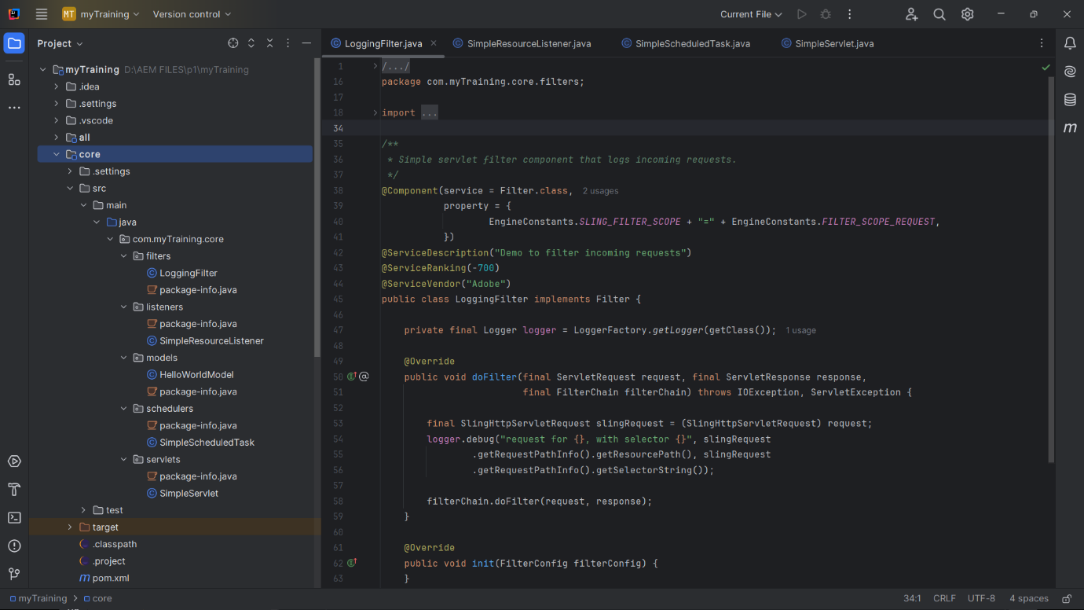

* Filters
* Listeners
* Models
* Schedulers
* Servlets
* Pom.xml

1. Explain the role of ui.apps in AEM projects.

*The ui.apps module is where all frontend logic and components are stored. It contains Clientlibs , templates and components.*

1. How are components structured in the ui.apps folder?

*The components folder has all the required assets for the frontend of the project. It contains forms, elements etc.*

1. **Hello World Component:**

* Where is the Hello World component located in both core and ui.apps ?

*In ui.apps it is located in the components folder whereas in core it is located in the models* .

* Explain the Java class (in core) for the Hello World component.

*This class is a Sling Model that retrieves data from the JCR and makes it available to the UI.*

* How does the HTL script work in ui.apps for Hello World ?

*HTL (formerly Sightly) is used instead of JSP to display dynamic data in AEM components. Uses expressions like ${model.propertyName} to display values.*

* How are properties and dialogs defined for this component?

*In AEM, properties and dialogs for the Hello World component are defined in the ui.apps module using XML files inside the component’s folder.*

1. What are the different types of AEM modules (core, ui.apps, ui.content, etc.)?

*The core module handles backend logic using Sling Models, OSGi services, and servlets. The ui.apps module defines frontend components, dialogs, and client libraries. The ui.content module stores AEM site content, templates, and initial content. Additional modules like ui.frontend, ui.config, it.tests, and dispatcher help with frontend development, configurations, testing, and caching*.

1. How does Maven build these modules?

*Maven follows a structured build process:*

*1.Compiles Java code (core module)*

*2.Packages frontend resources (ui.apps module)*

*3.Generates an AEM package (.zip or .jar)*

*4.Deploys the package to AEM*

*The all module combines everything into a single installable AEM package.*

1. Explain the build lifecycle of Maven in the context of AEM.

Maven runs in phases:

*clean – Deletes previous build files*

*compile – Compiles Java files*

*package – Packages AEM modules*

*install – Installs locally*

*deploy – Deploys to an AEM instance*

*Each phase is triggered by commands like mvn clean install*.

1. How are dependencies managed in pom.xml ?

*The pom.xml file defines all dependencies (libraries) needed for the AEM project.*

*It pulls required AEM APIs and plugins automatically from Adobe’s Maven repository.*

1. Why is Maven used instead of other build tools ?

Maven is preferred for AEM because:

It standardizes project structure and automatically resolves dependencies which provides AEM-specific plugins for packaging and deployment

1. What advantages does Maven offer for AEM development?

*It standardizes project structure, making it easier to manage large AEM projects. With build automation, you can compile code, deploy bundles, and package content with a single command*

1. How does Maven help in managing dependencies and plugins in AEM projects?\

*Maven helps in managing dependencies and plugins using the pom.xml file*

1. What does mvn clean install do in an AEM project?

*It cleans old builds and compiles java code then packages AEM components and installs the package locally*

1. How to deploy packages directly to AEM using Maven commands ?

*It can be done by using this command “mvn clean install -PautoInstallSinglePackage”*

1. Explain the purpose of different Maven profiles in AEM (autoInstallPackage, autoInstallBundle).

*Maven profiles in AEM help deploy specific parts of the project efficiently. autoInstallPackage installs the full project (backend + frontend), while autoInstallBundle only deploys the core OSGi bundle (Java code). autoInstallSinglePackage does a quick full deployment in one step. These profiles make AEM development faster by avoiding unnecessary re-installations.*

1. What is the purpose of dumplibs in AEM ?

*dumplibs in AEM is a debugging tool for client libraries (CSS & JS). It helps check if clientlibs are loading correctly and shows their dependencies*

1. How can you view client libraries using dumplibs?

Using : http://localhost:4502/libs/granite/ui/content/dumplibs.html

1. Explain how client libraries are structured in AEM.

*Client libraries (clientlibs) in AEM are used to manage CSS, JavaScript, images, and other static assets efficiently. They follow a structured format and are stored under:*

*/apps/project/clientlibs/*